


Rhythm Insight RT
Efficient and secure image acquisition for precise inspection and process optimization

Inspection starts here 

Image acquisition in seconds, learnable in a day and useful for a lifetime

With a flexible architecture, efficient workflow, data-integrity and security, Rhythm Insight RT gives you software that maximizes the power of your radiographic imaging systems - from film digitization (FD), through computed radiography (CR), to digital detector array (DDA) radiography.

With Rhythm Insight RT software, you receive a portfolio of advanced image acquisition, analysis and DICOM/DICONDE compliant data management tools for your digital radiogra- phy NDT inspection methods.

Rhythm Insight RT features at a glance:
- Scalable, state-of-the-art technology
- Dedicated to industrial requirements
- Intuitive user interface for out-of-the-box scanning and image processing
- Application-guided automation
The software platform is built on 15 years of proven knowledge and customer insights, ensuring optimal readiness for the future.
- Powered by Flash! intelligent image processing
- Powerful image quality validation and DICONDE compliant tools
- Expanded analysis features including auto- canvas sizing and metadata cloud export

Scalable and Safe
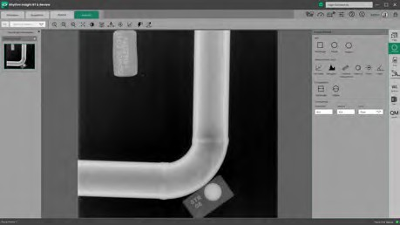
The secure, scalable architecture enables Rhythm Insight RT to grow right along with you, meeting your inspection workflow needs as they evolve. Capable of capturing both static and real-time detector images, Rhythm Insight RT is fully prepared for upcoming advanced technologies in field radiography. DICOM/ DICONDE compliance ensures
that your data never becomes obsolete – further protecting your imaging assets. Roles- aware workflow supports cradle-to-grave manage- ment of inspections. Improve your team’s performance and securely inspect terabytes of studies.

2

Fast Image Acquisition and Optimal Analysis
With Rhythm Insight RT, you can send infor- mation electronically to the inspection experts, sharing it across your network.
Application-specific tools further enhance inspection efficiency, allowing the automation of repeating inspection cycles. Rapid standards-compliant calibration and qual- ity tools permit analysis in quick preliminary analysis.

Your user experience: a touch above
Rhythm Insight RT offers you an improved and simplified user experience. The touch user interface enables operation under even harsh environments. Operation is easier and fast- er, enhancing efficiency and reproducibility, while the risk of errors and production defects is reduced to a minimum. Quick and easy to learn, Rhythm Insight RT keeps user training requirements to a minimum, allowing opera- tors to be up and running instantly. Level 1 and 2 X-ray users can get up to speed in less than a day.

Powered by Flash! intelligent image processing technology

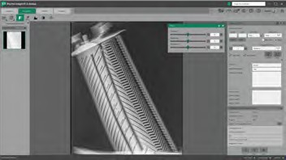
Rhythm Insight RT comes with Flash! intelligent image processing built right in. Combining 25+ years of experience and patents with next-generation technology, Flash! automatically, quickly and consistently optimizes your digital radiographs.
You get exquisite image quality and comfortable reading, with a faster, smoother workflow that enhances your productivity, maximizes your resources and gives your customers peace of mind.



Sharp
Innovative, proven and leading image processing technology offering high image quality and consistent images, regardless of the operator.


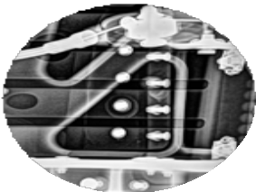Smart

One Click
Clear vision of both high- and low-density areas, with automatically minimized noise and maximized details.

Simple
Easy to learn and use, without specialized training. Easier reading and confident reviewing are combined with simpler usage, as you view all the layers in a glance without man- ual adjustments. Flash! is operator independent, automati- cally adjusting to variations in
density, materials, geometry, radiation quality, etc. Oper- ator and inspector alike save time and effort, giving you more from your human and material resources.
3

Rhythm Insight offer
Rhythm Insight is offered with two licensing scenarios.

Perpetual license
Subscription license

- One-time fee
- Software with optional but recommended Remote Support
- Basic updates available for 2 years. Afterwards, updates and major upgrades can be purchased separately.
- Billed annually
- Full access to the software plus a bunch of services including hours for remote services, training classes online and offline, and consulting experts
- Access to all updates for the lifetime of the subscription

InspectionWorks
The smart new way to acquire, analyze and act on inspection data

Rhythm Insight RT is part of InspectionWorks, the agnostic software platform of Waygate Technologies to collect, connect, integrate, and share NDT data in a single, secure and scalable platform.

Enrich your data and gain actionable insights with AI and DL engines that help you make better decisions, faster.
Streamline workflows and inspection processes and easily collaborate across teams – even remotely.

Improve the performance and uptime of your NDT fleet with remote monitoring and diagnostics.

Rhythm Insight Lite

Rhythm Insight Lite offers an economical and easy-to-use tool for digital image management, especially for users converting from film to digital devices.
The powerful toolset enables you to easily acquire, evaluate and store digitized radio- graphs. Rhythm Insight Lite is completely compatible and upgradable to the more advanced Rhythm Insight RT platform.

Meeting international standards

In addition to Flash!, Rhythm Insight provides you with a set of image quality validation tools that meet a range of international standards, including DICONDE, ISO, ASTM, EN, ASME, JIP and KATS.



